Semester Project

1. List the total payout that Brakus Inc made for the first quarter of 2017.

SQL Statement Goes Here.

select to_char(sum(insure_amount), '$9,999,999.99') "first quarter payout" from INSURE_PAYMENT

where INSUR_CODE= (select INSUR_CODE from insurance

where insur_name = 'Brakus Inc')

and INSUREPAY_DATE between '01-Jan-17' and '30-Apr-17';

Screen Shot Goes Here

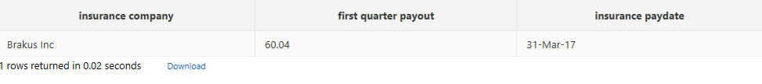

1. List the total payout by check Brakus Inc made for 2017.

SQL Statement Goes Here.

select to_char(sum(insure_amount), '$9,999,999.99') "first quarter payout" from INSURE_PAYMENT

where INSUR_CODE= (select INSUR_CODE from insurance

where insur_name = 'Brakus Inc')

and INSUREPAY_DATE between '01-Jan-17' and '30-Dec-17'

and INSUREPAY_TYPE = 'Check' ;

Screen Shot Goes Here



1. List the patients Dr. Bettlestone treated in 2017.

SQL Statement Goes Here.

select PAT_LNAME "Patient" from PATIENT

where PAT_NUM = any (select PAT_NUM from VISIT

where DOC_ID = (select DOC_ID from DOCTOR

where DOC_LNAME = 'Bettlestone')and VISIT_DATE between '01-JAN-17' and '31-DEC-17');

Screen Shot Goes Here

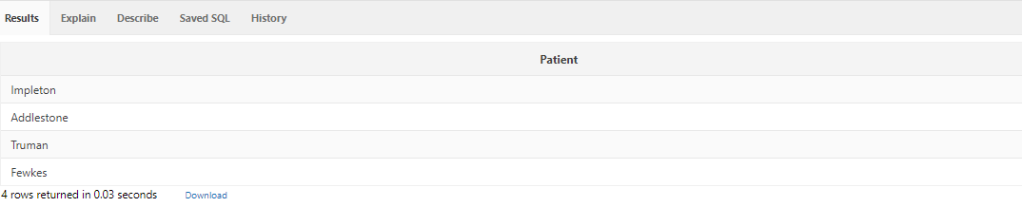

1. List the patients Dr. Bettlestone treated in 2017 during the morning.

SQL Statement Goes Here.

select PAT_LNAME "Patient" from PATIENT

where PAT_NUM = any(select PAT_NUM from VISIT

where DOC_ID=(select DOC_ID from DOCTOR

where DOC_LNAME = 'Bettlestone')

and VISIT_DATE between '01-JAN-17' and '31-DEC-17'

and VISIT_TIME like '%AM');and APPT_SCHED is null;

Screen Shot Goes Here

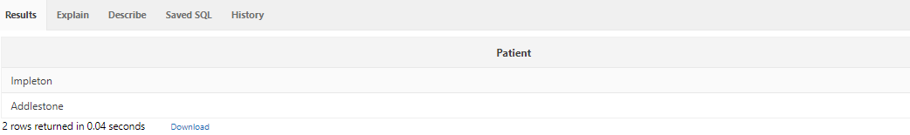

1. List the patients that did not have an appointment but were seen by a doctor.

SQL Statement Goes Here.

select distinct doctor.doc_Lname as "doctor", PATIENT.pat_lname as "patient" ,APPOINTMENT.appt_sched as "no appointment"

from APPOINTMENT,PATIENT,DOCTOR

where doctor.doc_id=APPOINTMENT.doc_id

and PATIENT.pat_num=APPOINTMENT.pat_num

and APPT_SCHED is null;

Screen Shot Goes Here

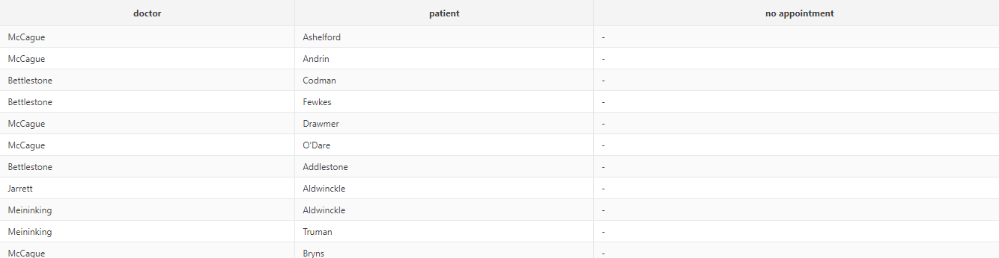

1. List all the doctors and what they billed out in 2017. HINT: Use the DOCTOR table and the VISIT table.

SQL Statement Goes Here.

select distinct doctor.doc_Lname as "doctor", to_char(sum(VISLINE_CHARGE), '$999,999,999.99') as "2017bill"

from DOCTOR,Visit

where doctor.doc_id=visit.doc_id group by (doc_Lname);

Screen Shot Goes Here

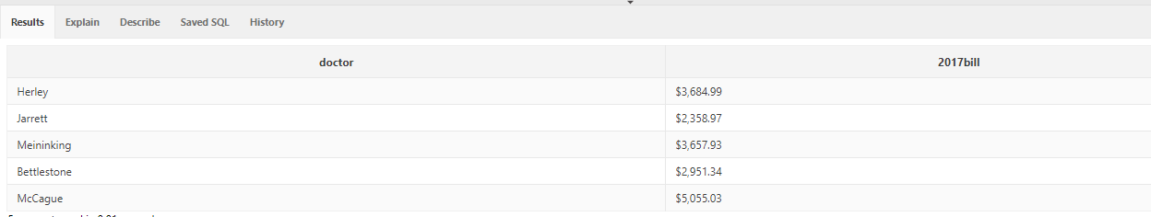

1. Determine and list what each patient’s balance is including those with null balance. HINT: Use just the PATIENT table.

SQL Statement Goes Here.

select PAT_LNAME as "patient name",to_char(nvl(PAT_BALANCE,null), '$999,999,999.99') as "patient balance" from patient;

Screen Shot Goes Here

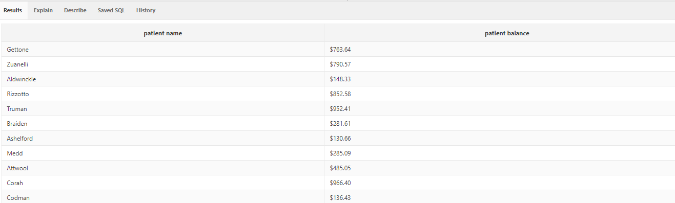

1. Determine and list which patient’s balance is less than the average balance of all the other patients. HINT: Use just the PATIENT table.

SQL Statement Goes Here.

select pat_num,pat_fname ||','||Pat_lname as "patient", to_char(nvl(pat_balance,null), '$999,999,999.99') as "patient balance"

from patient

where nvl(pat_balance,null)<(select avg(nvl(pat_balance,null)) from patient);

Screen Shot Goes Here

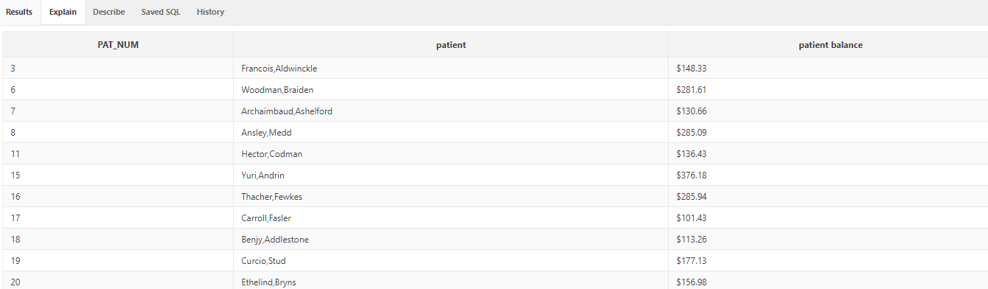

1. In ONE SQL command create a new table named NEW_PATIENT, copy over all of the columns except for pat_balance. Drop PATIENT table, rename NEW_PATIENT to PATIENT.

Drop the column BILL_PAY_AMOUNT from the table BILLING.

SQL Statement Goes Here.

create table new_patient

as( select PAT_NUM,

PAT_LNAME,

PAT_FNAME,

PAT_PHONE,

PAT_EMAIL,

INSUR_CODE from patient);

drop table patient;

rename new_patient to patient;

alter table BILLING drop column BILL_PAY_AMOUNT ;

Do not need a screen shot for this question.

1. Who/whom has a diagnostic of “asthma”?

SQL Statement Goes Here.

select pat_num as "patient ID",patient.pat_lname as patient from patient where pat_num = (select pat_num from visit where VISLINE_DIAGNOSIS like '%asthma%' );

Screen Shot Goes Here

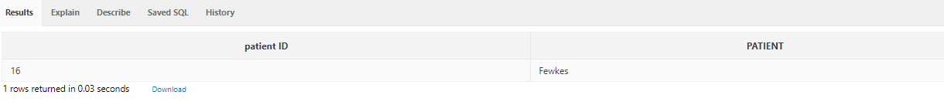

1. EXTRA CREDIT: What is Francisco Drawmer balance?

SQL Statement Goes Here.

select to_char(sum(bill_balance),'$999,999,999.99') as "balance" from billing

where bill_code = (select bill_code from pat_payment

where pat_num = (select pat_num from patient

where pat_Lname = 'Drawmer'));

Screen Shot Goes Here

